# Author: Charles Hoan Duong Date: 17.12.2023

Topic: How to create a new Maven Project with CRUD REST API, H2 Database, JPA and Spring Boot

**Prerequisites**

1. Java installed

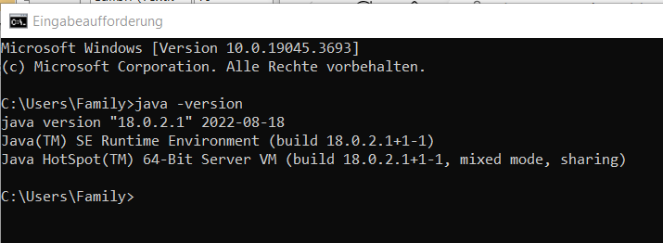

1. javac - Java compiler installed.

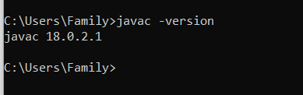

1. Your favorite Java IDE installed. Intelli-J, Eclipse etc.

**Project setup**

The easiest way to create a new spring boot application is to use the spring initializr.

* Open spring initializr > <https://start.spring.io/> in your web browser.  
  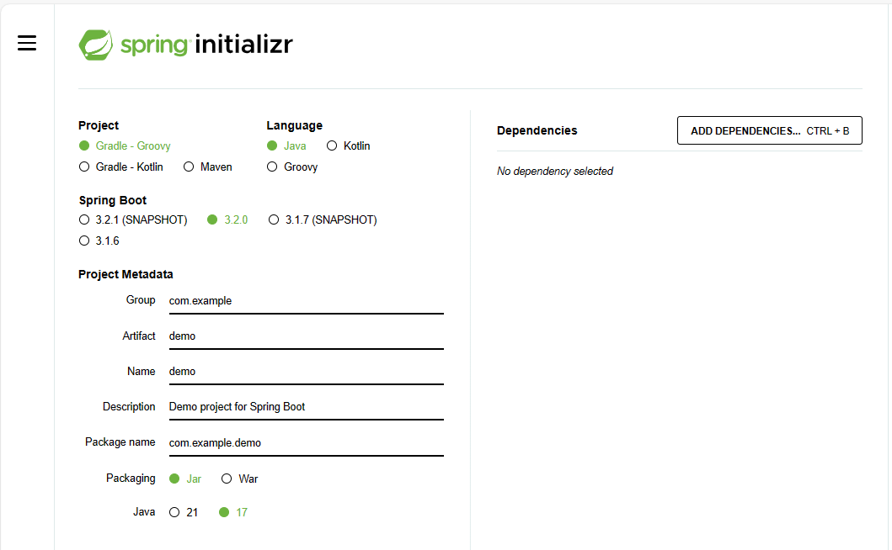
* Choose the Maven project.
* Choose Java as the language.
* Leave the default selected Spring Boot version. e.g: 3.2.0 (You can change to other version in your pom.xml on the generated Maven project later)
* Provide Group and Artifact Name with some Description.
  + Example (You can give any information you want)
  + Group: come.fitness
  + Artifact: springboot-rest-h2-jpa-webapp
  + Name: springboot-rest-h2-jpa-webapp
  + Description: Spring Boot Project with Rest H2 JPA
  + Package name: com.fitness.springboot-rest-h2-jpa-webapp
* Select Java (e.g: 17) as the Java Version. (You can change to other version in your pom.xml on the generated Maven project later)

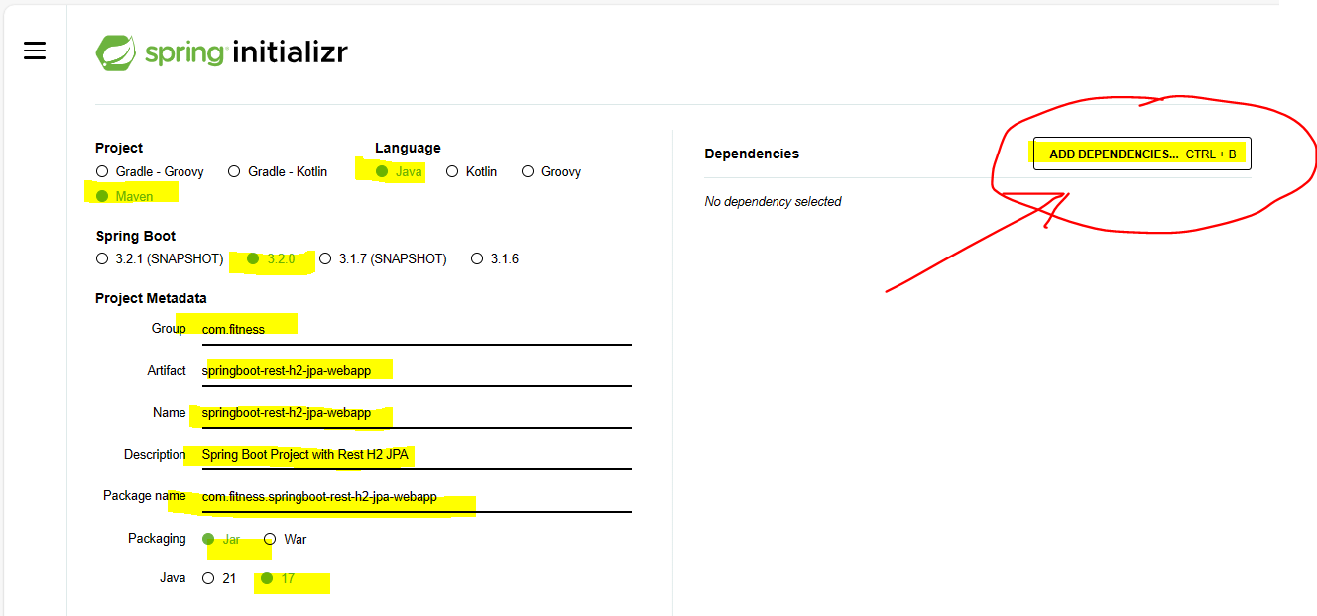

* Click ADD DEPENDENCIES Button.
* In the dependencies section add
  + **Lombok**, Spring Web, H2 Database, Spring Data JPA & Actuator as the dependencies.
* Click Lombok.

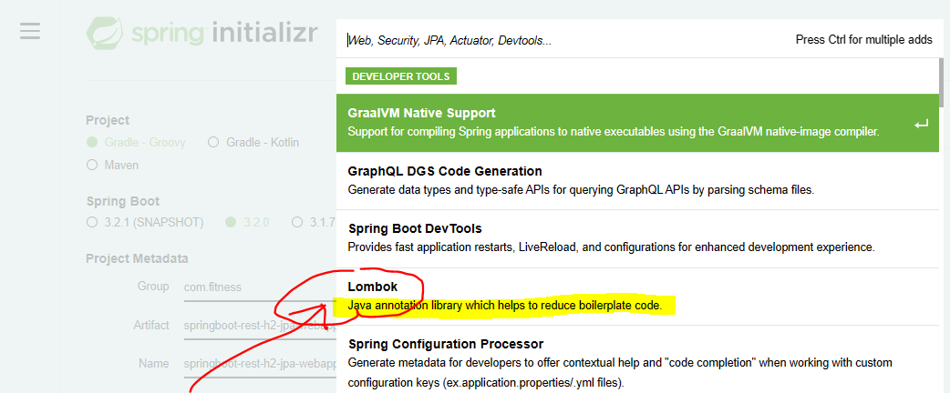

* Lombok is added. Click ADD DEPENDENCIES Button

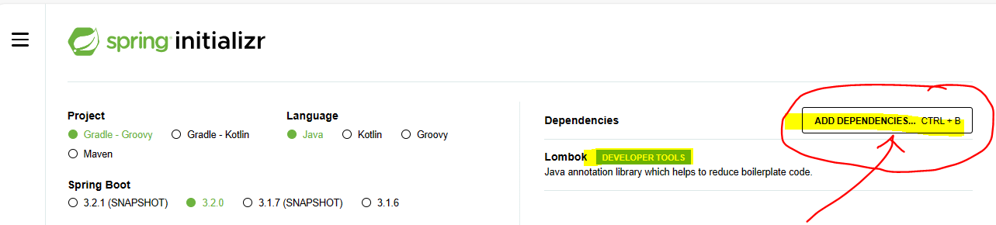

* Click Spring Web

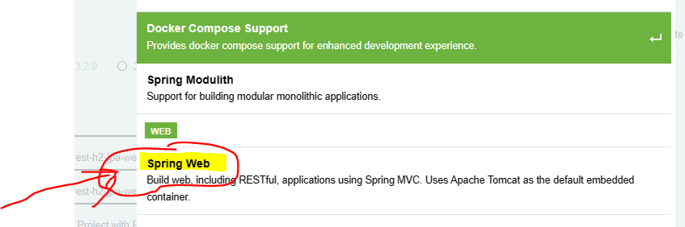

* Sprint Web is added. Click ADD DEPENDENCIES Button

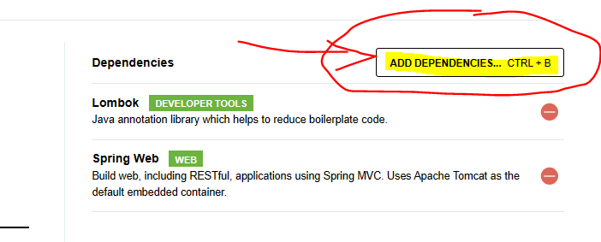

* Click H2 Database.

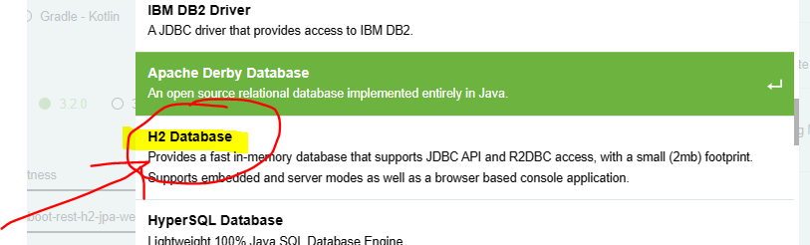

* H2 Database is added. Click ADD DEPENDENCIES Button.

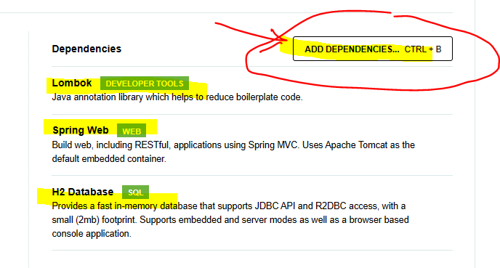

* Click Spring Data JPA

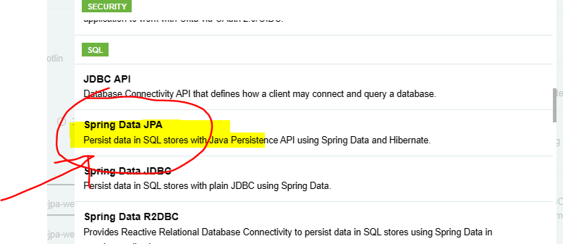

* Spring Data JPA is added. Click ADD DEPENDENCIES Button.

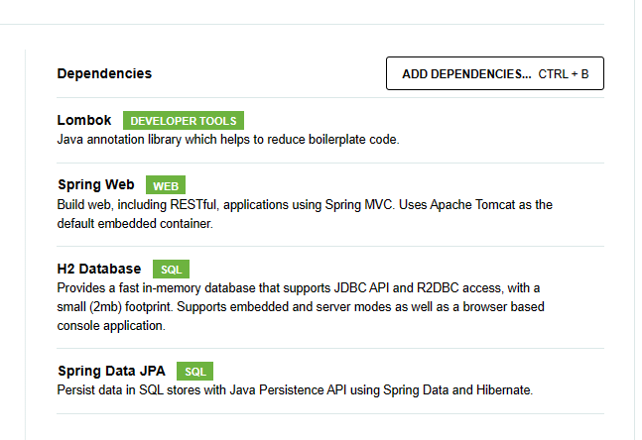

* Click Spring Boot Actuator

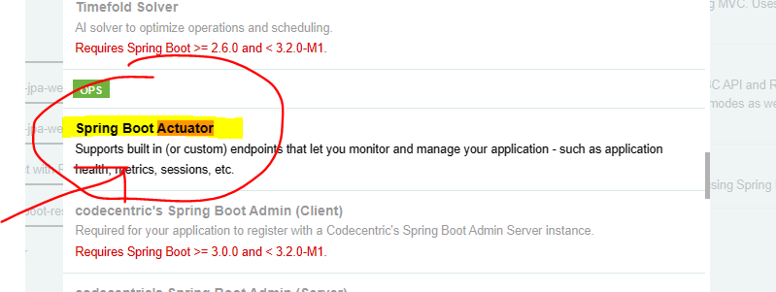

* Spring Boot Actuator is added. All Dependencies are added. OK 😊
  + In the dependencies section add   
    Lombok, Spring Web, H2 Database, Spring Data JPA & Actuator as the dependencies.

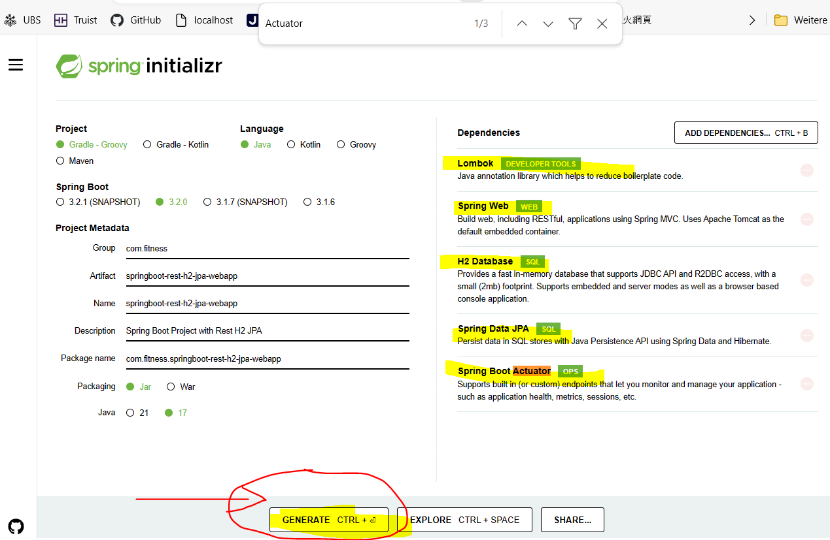

* Click on the GENERATE Button to download the project as a zip file.
* A springboot-rest-h2-jpa-webapp.zip is generated and can see in the Downloads.

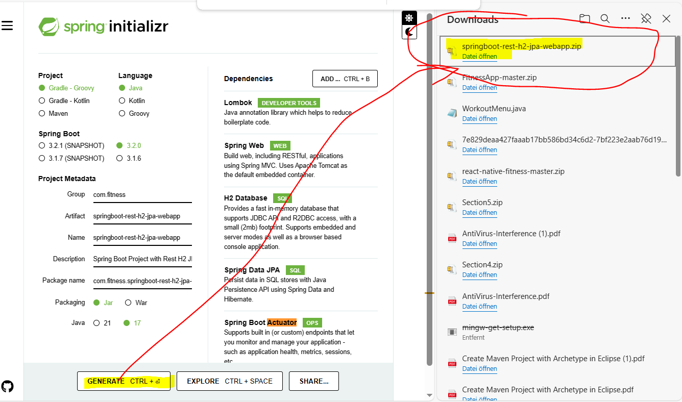

* Extract the zip file and open the project in your favorite IDE (IntelliJ, Eclipse etc.)

For instant: Put the springboot-rest-h2-jpa-webapp.zip under my folder: C:\Users\Family\git

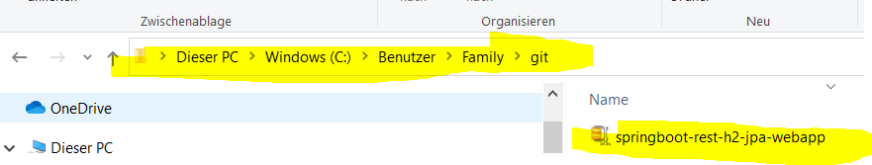

* Unzip springboot-rest-h2-jpa-webapp.zip

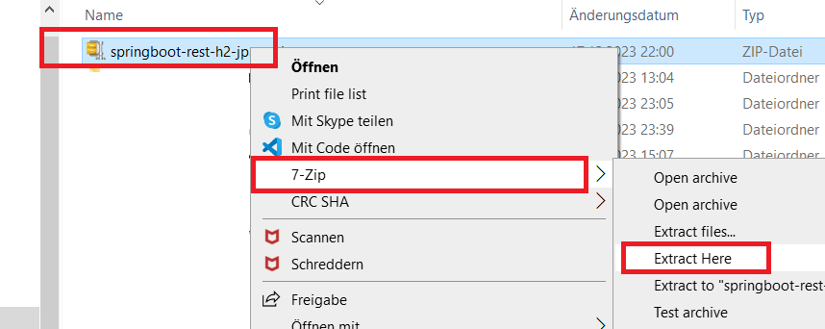

* A new “Maven Project with CRUD REST API with H2 Database and JPA and with Spring Boot” is created with project name: springboot-rest-h2-jpa-webapp

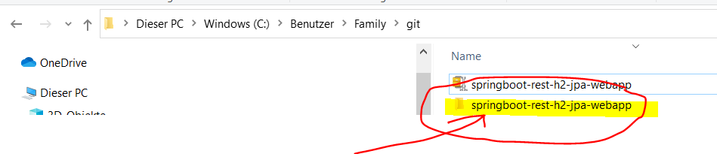

* Click on Maven script pom.xml

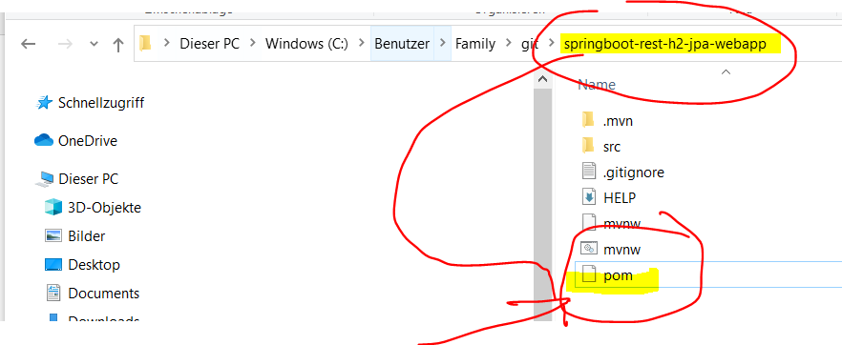

pom.xml included all the selected dependencies:

* + In the dependencies section add   
    Lombok, Spring Web, H2 Database, Spring Data JPA & Actuator as the dependencies.

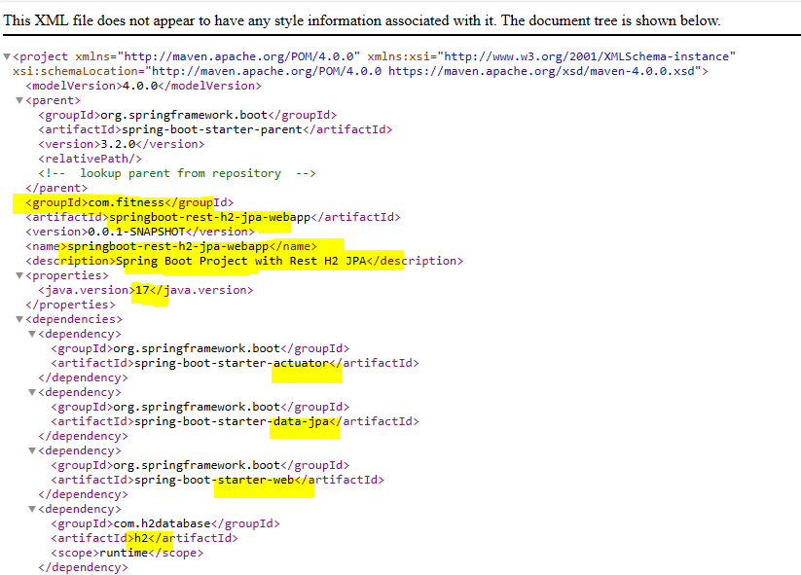

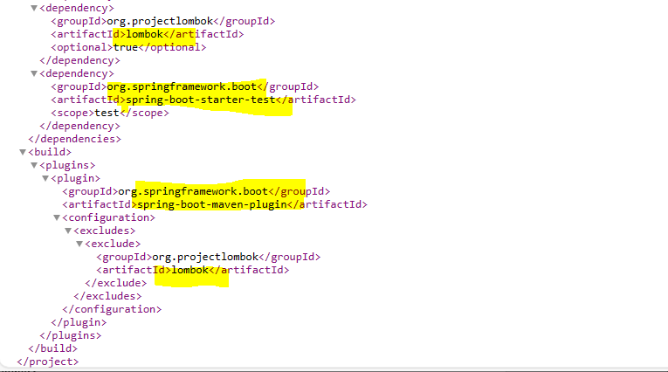

I use Eclipse, on Eclipse clicking Import.

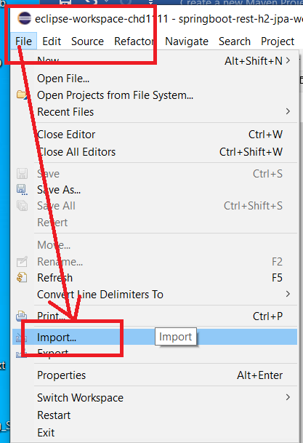

* Click Exsiting Maven Projects.

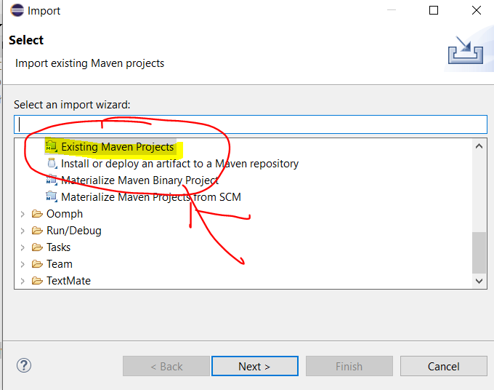

* Select generated Maven project springboot-rest-h2-jpa-webapp under my folder C:\Users\Family\git

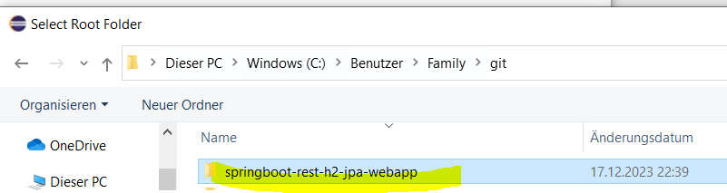

* Click Ordner auswählen (English: Select folder)

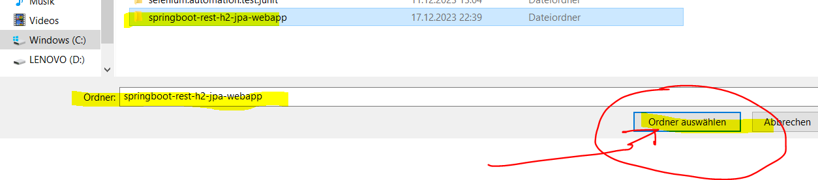

* Click Finish

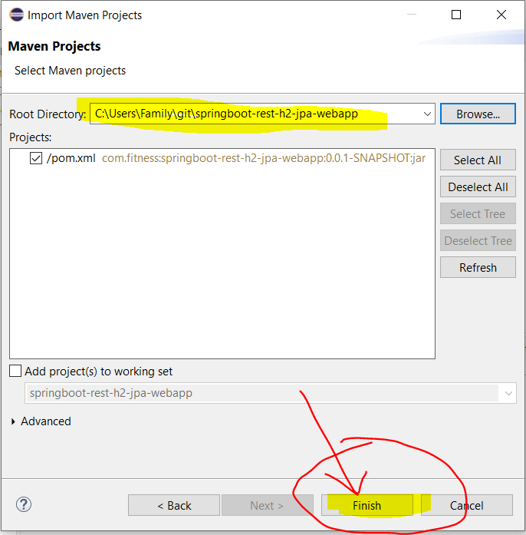

* On generated Maven springboot-rest-h2-jpa-webapp project. Under

../src/main/java >

com.fitness.springbootresth2jpawebapp >

Right Click SpringbootRestH2JpaWebappApplication >

Select Run As >

Click Java Application

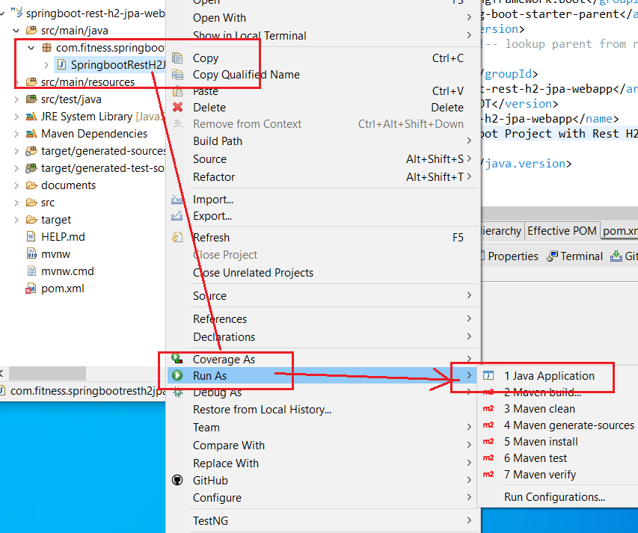

* The SpringbootRestH2JpaWebappApplication is running successfully on Port 8080.

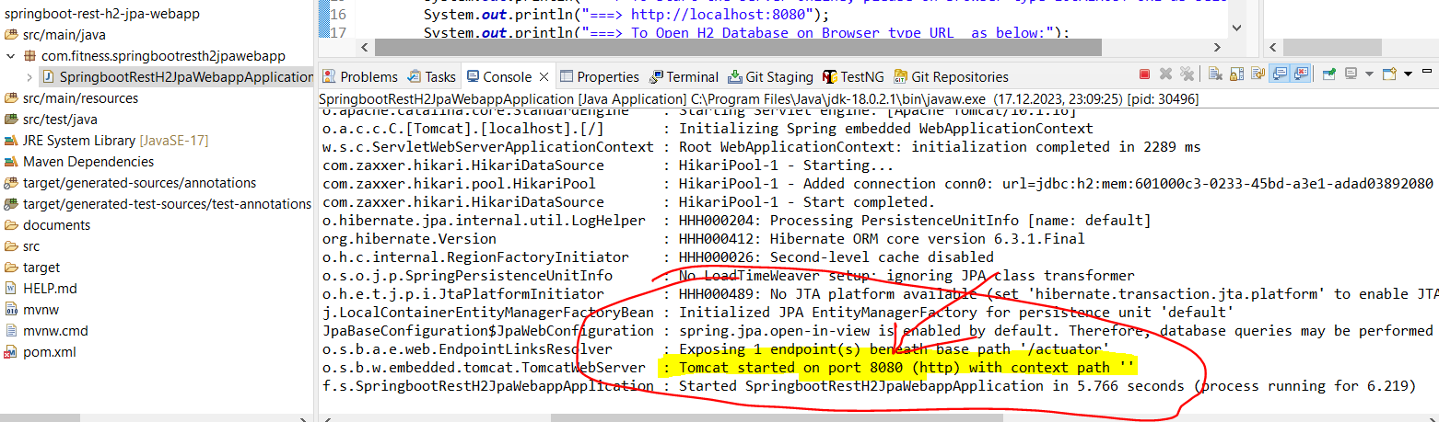

* Open Browser  (Google Chrome oder Edge etc.) type <http://localhost:8080/actuator>. If you see the following information. then

Well DONE. 😊

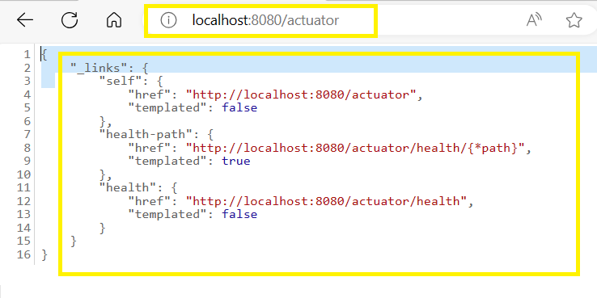

* If The Port 8080 was already use.

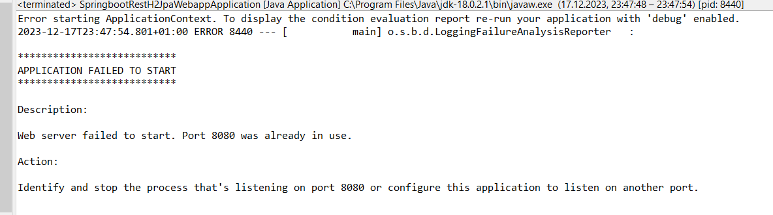

* On Window, you can use   
  netstat -ano | findstr :8080

to find out the PID Process-ID (In my case is 19992)  
then use   
taskkill /PID 19992 /F

to kill the PID, and then run the SpringbootRestH2JpaWebappApplication again and all will be ok.

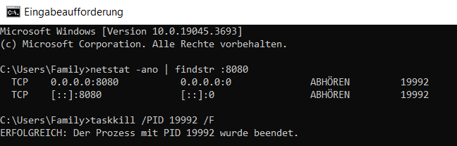

-- FINISH --